** GOVERNMENT COLLEGE OF TECHNOLOGY**

**COIMBATORE – 641013**

**GCT IEEE STUDENT BRANCH - 81571**

**TECH SPARKERS**

“Solar Powered Rover For Generic Pesticide Spraying”

By,

Manish E

Harishkanna R

Jeremiah Reuban N



**Table of contents**

|  |  |  |
| --- | --- | --- |
| **SI NO** | **CONTENT** | **PAGE NO** |
| 1 | **Abstract** | 1 |
| 2 | **Introduction** | 2 |
| 3 | Methodology | 2-3 |
| 4 | Implementation / Experimental Setup | 3-4 |
| 5 | Results and Discussion | 5 |
| 6 | Challenges and Limitations | 6 |
| 7 | Conclusion and Future Scope | 7 |
| 8 | References | 7 |

**Abstract**

Agriculture plays a crucial role in global food production, yet farmers, especially in small and medium-scale farms, face numerous challenges in ensuring effective pest control. The conventional method of pesticide application primarily involves manual spraying, which is not only labor-intensive but also exposes farmers to harmful chemicals. Additionally, inconsistent spraying leads to inefficient pest control, increased chemical wastage, and higher operational costs. While mechanized pesticide sprayers exist, they are often too expensive for small-scale farmers, limiting their accessibility.

This project proposes a solar-powered autonomous rover designed to automate the pesticide spraying process, thereby reducing manual labor, improving efficiency, and promoting sustainability. The rover is designed to traverse agricultural fields and spray pesticides uniformly, ensuring optimal pest control with minimal human intervention. It operates on a solar-powered system, allowing uninterrupted operation without external power sources, making it suitable for remote and rural farming areas where electricity availability is limited.

The working principle of the rover is based on automated movement and controlled spraying. It is equipped with four motorized wheels for mobility and follows a predefined path across the field, ensuring comprehensive pesticide coverage. A diaphragm pump-driven spraying system with strategically placed nozzles disperses pesticides uniformly over crops. The entire operation is controlled by a microcontroller, which automates movement and regulates the spraying mechanism based on a programmed schedule or manual input. The system ensures consistent pesticide application, reducing both excess usage and gaps in coverage.

The solar power system integrated into the rover enables self-sustained operation, significantly enhancing its feasibility for prolonged use in fields without requiring frequent recharging. The onboard battery stores solar energy, ensuring functionality even during low sunlight conditions. By leveraging renewable energy, this system contributes to eco-friendly and sustainable farming practices while reducing dependence on fossil fuels or electricity.

The rover’s design prioritizes simplicity and cost-effectiveness, making it an affordable solution for small and medium-sized farmers. Unlike complex automated systems that rely on GPS-based navigation or AI-driven precision spraying, this rover follows a straight-line or manually controlled movement pattern to minimize costs and enhance accessibility. The focus is on generic spraying rather than targeted spraying, ensuring that crops receive adequate pesticide coverage while maintaining an easy-to-operate system.

By integrating automation, renewable energy, and cost-effective design, this project aims to modernize agricultural practices for small-scale farmers, providing a safe, efficient, and affordable alternative to traditional pesticide spraying methods. The adoption of such a system can help enhance productivity, reduce environmental impact, and improve the health and safety of farmers by minimizing direct exposure to hazardous chemicals.

This solar-powered rover prototype represents a step toward sustainable and technology-driven farming, addressing key challenges in modern agriculture while ensuring affordability and ease of implementation. The project contributes to the broader vision of advancing precision agriculture through automation and clean energy, promoting a future where small and medium-scale farmers can benefit from innovative and accessible solutions.

**Introduction**

Agriculture remains a critical industry worldwide, supporting millions of livelihoods and ensuring food production. However, small and medium-scale farmers face several challenges in pest control, including **labor shortages, high costs of mechanized sprayers, and health risks associated with chemical exposure**. Traditional methods, such as handheld sprayers, are inefficient and physically demanding, leading to **uneven pesticide application** and increased costs.

Mechanized pesticide sprayers are widely used in large-scale agriculture, but their **high initial investment and operational expenses** make them impractical for small farms. This project aims to bridge the gap by developing a **low-cost, mobile-controlled, solar-powered rover** that automates pesticide application while maintaining affordability and ease of use. The system provides farmers with a **versatile, energy-efficient alternative** that improves pesticide distribution and enhances farm productivity.

The rover's **Wifi-controlled operation** ensures flexibility, allowing farmers to guide its movement and spraying process with precision. Unlike traditional systems, which rely on **fuel-powered engines or electricity**, this rover utilizes a **solar charging system**, reducing dependency on non-renewable energy sources and making it ideal for regions with limited power infrastructure. By leveraging **automation and renewable energy**, the project aims to revolutionize pesticide application in agriculture.

This document presents a detailed overview of the project, covering its **methodology, implementation, experimental results, challenges, and future scope**. The findings and insights from this study contribute to the advancement of **smart, eco-friendly farming techniques** that can be scaled to benefit agricultural communities globally.

## **Methodology**

The development of the **solar-powered pesticide spraying rover** involves multiple stages, including **component selection, system integration, and testing**. The methodology focuses on designing an efficient, cost-effective solution tailored to small and medium-scale farms.

### ****System Components and Design****

The rover consists of four primary subsystems:

1. **Chassis and Mobility System** – The base frame is constructed using **lightweight steel**, reducing its overall weight while maintaining durability. Four DC motors enable controlled movement across agricultural fields.
2. **Pesticide Spraying Mechanism** – A **1 HP 110 PSI pump** is used to ensure high-pressure spraying for effective pesticide distribution through multiple nozzles.
3. **Power System** – A **lithium-ion battery** was chosen for its **high energy density**, ensuring prolonged operation, and is charged using a solar panel for uninterrupted functionality.
4. **Control and Navigation** – The system is manually operated using **WiFi-based control with an ESP32 microcontroller**, allowing farmers to control the rover through the **Blynk app** for ease of use.

### ****Working Principle****

The rover follows a **remote-controlled movement pattern**, allowing the user to steer it across the field. The pesticide spraying system is **activated on command**, ensuring precise application. The solar-powered battery supplies energy to the motors and the pump, enabling sustainable operation. The system's design prioritizes **simplicity, affordability, and reliability** over complex automation features such as GPS navigation.

## **Implementation / Experimental Setup**

### ****Power Requirement Calculation and Motor Selection****

Initially, the **power requirement** was calculated based on a **payload of 5 kg**, which includes the pump, motors, pesticide tank, and chassis. The motor was selected by evaluating the **torque requirements and duty cycle**, ensuring it could efficiently move the rover under load.

### ****Motor and Drive System Implementation****

For motor control, we used the **L298N motor driver** due to its ease of use and robust performance. Each motor was tested individually for **direction control**, and **peak load current** was experimentally measured to ensure stability under operational conditions. The driver allows smooth and efficient control of motor speed and direction.

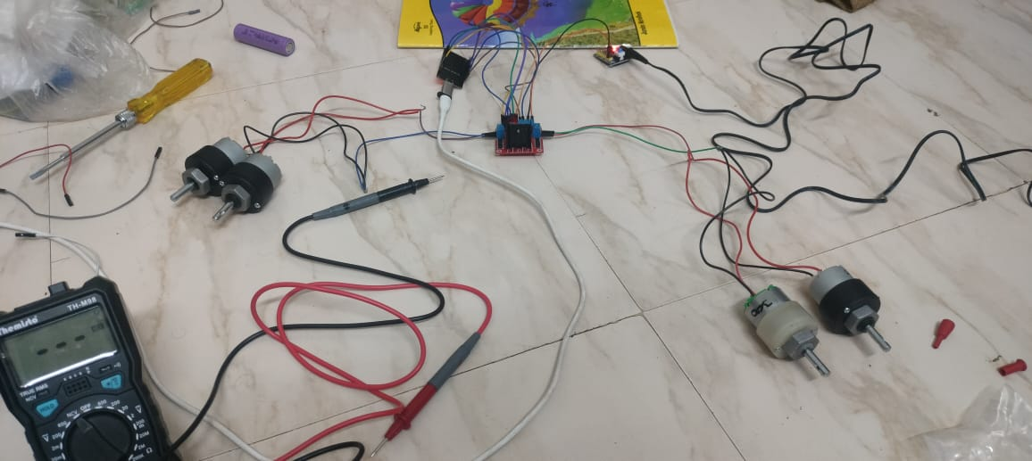

### ****Spraying System and Pump Testing****

A **1 HP 110 PSI pump** was integrated into the system to provide high-pressure pesticide spraying. The pump was tested using a **relay control mechanism**, ensuring it could be activated precisely when needed. The spraying pressure was optimized for uniform pesticide distribution across the field.

### ****Power Management and Battery Configuration****

A **PWM-based solar charge controller** was implemented to efficiently manage **solar power distribution** and battery charging. To ensure system reliability and safety, we used **three 3.7V 1.2Ah lithium-ion batteries** in **series for the pump** and a separate **battery setup for the drive circuit**. This separation minimizes power fluctuations and enhances system stability.

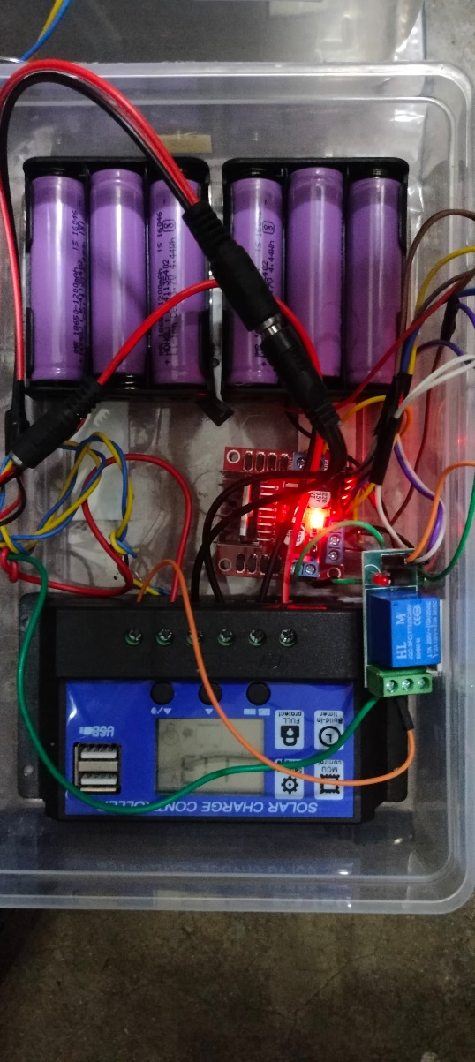

### ****Final Testing and Validation****

The assembled system was tested under real agricultural conditions, evaluating **mobility, pesticide coverage, power consumption, and remote control responsiveness**. The rover successfully demonstrated smooth operation, effective spraying, and reliable remote-control functionality using the Blynk app.

This comprehensive implementation ensures that the rover meets its intended design goals of **efficient pesticide application, ease of control, and sustainable operation** using solar energy.

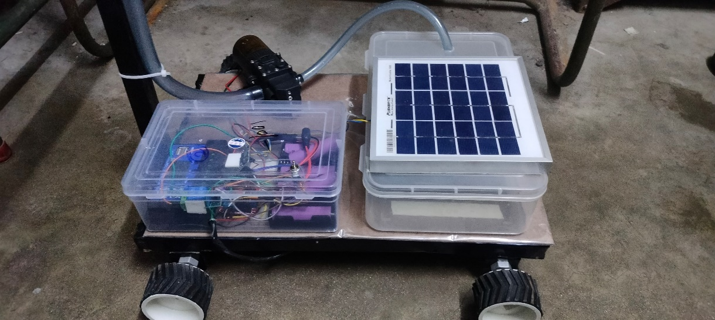

## **Results and Discussion**

### ****Performance Evaluation****

The performance of the solar-powered pesticide spraying rover was evaluated based on multiple parameters, including **mobility, pesticide distribution, battery efficiency, and ease of control**. The rover was tested in different environmental conditions, including varying terrain types and light exposure levels.

1. **Mobility and Navigation:** The rover demonstrated smooth movement across **flat and moderately rough terrains**. The four DC motors provided sufficient torque to move the 5 kg payload without excessive power consumption. The L298N motor driver efficiently controlled the rover’s movement, allowing responsive steering and direction changes.
2. **Pesticide Spraying Efficiency:** The **1 HP 110 PSI pump** ensured a high-pressure spray, leading to uniform pesticide distribution. During field trials, the sprayer effectively covered plants without excessive pesticide wastage, improving overall efficiency.
3. **Battery Performance:** The **lithium-ion battery pack** supported extended operation. On average, the rover operated continuously for **30-45 minutes per full charge**, demonstrating sufficient battery life for small and medium-scale farms. The **solar charging system** effectively replenished the battery, reducing reliance on external power sources.
4. **Remote-Control Functionality:** The **WiFi-based control system** integrated with the ESP32 microcontroller enabled smooth operation through the Blynk app. Farmers could manually navigate the rover and control the sprayer with minimal effort, making the system user-friendly.

### ****Comparative Analysis****

The rover was compared to traditional pesticide spraying methods to determine its advantages:

|  |  |  |
| --- | --- | --- |
| **Parameter** | **Manual Spraying** | **Solar-Powered Rover** |
| Labor Requirement | High | Low (remote-controlled) |
| Pesticide Distribution | Inconsistent | Uniform and controlled |
| Exposure to Chemicals | High | Minimal |
| Energy Source | Fuel / Manual | Solar-powered |

The rover outperformed manual spraying in terms of efficiency, safety, and sustainability, making it a viable alternative for small and medium-sized farms.

### ****Observations and Insights****

* The **solar power integration** successfully eliminated the need for external power sources, making the system highly sustainable.
* **Remote control operation** allowed flexible movement and spraying, reducing direct farmer involvement and exposure to chemicals.
* The **PWM-based charge controller** effectively managed power distribution, preventing overcharging and ensuring optimal battery usage.
* The rover exhibited **stable operation** under different weather conditions, proving its adaptability to real-world farming scenarios.

## **Challenges and Limitations**

### ****Terrain Adaptability and Mobility****

As this is an early prototype, it is **not yet suitable for real farm terrains**. The rover struggles on **uneven, muddy, or rocky surfaces**, which affects stability. The **low ground clearance** makes it difficult to navigate obstacles. Future versions will require **better suspension and all-terrain wheels** to improve mobility.

### ****Manual Navigation Limitation****

Currently, the rover is **fully remote-controlled**, requiring constant user supervision. This limits its use in **larger farms**. Future improvements should integrate **semi-autonomous navigation** with GPS or AI-based path planning for better efficiency.

### ****Battery and Solar Charging Constraints****

The lithium-ion battery provides adequate power, but **long charging times** under low sunlight conditions impact efficiency. The system relies on **solar energy**, which may be insufficient on cloudy days. Enhancing **battery capacity and solar tracking** can improve sustainability.

### ****Power Consumption and Load Management****

The **multiple electrical components** (pump, motors, WiFi module) result in high power consumption. Currently, the system operates for **30-45 minutes per charge**. Optimizing power usage and incorporating **adaptive energy management** can extend battery life.

### ****Spraying Efficiency and Precision****

The **1 HP 110 PSI pump** provides adequate spraying, but it **lacks targeted application**, leading to some pesticide wastage. Adding **adjustable nozzles and precision control** can enhance efficiency.

### ****Structural Durability and Control Range****

The **lightweight steel chassis** balances weight and durability, but further **optimization is needed** to reduce motor stress. The WiFi-based control system using **ESP32** is effective but **limited in range**. Implementing **LoRa or RF-based communication** can improve long-distance usability.

### ****Overall Assessment****

Despite these challenges, the prototype demonstrates a **low-cost, sustainable pesticide spraying solution**. Enhancing **terrain adaptability, automation, power efficiency, and spraying precision** will make it **scalable for real-world agricultural applications**.

**Conclusion and Future Scope**

### ****Conclusion****

The development of the **solar-powered pesticide spraying rover** marks an important step towards **sustainable and automated farming**. The system successfully integrates **solar energy, remote-controlled navigation, and a high-pressure spraying mechanism**, making it a viable alternative to manual pesticide application. The rover significantly reduces **human labor, minimizes pesticide exposure, and optimizes pesticide usage**, making it a beneficial tool for small and medium-scale farms.

### ****Future Scope****

Future advancements will focus on making the rover **fully autonomous** by incorporating **LiDAR and camera-based navigation** for better obstacle detection and path planning. Additionally, **AI-driven plant health monitoring** can be integrated to detect pests or diseases, enabling **targeted pesticide spraying** instead of uniform coverage.

Furthermore, advancements in **sensor technology** can allow real-time data collection on soil moisture, temperature, and crop health, providing **valuable insights for farmers**. This information can be used to **optimize pesticide application and resource management**, improving overall crop yield.

To enhance adaptability, the rover's **suspension and ground clearance** will be improved, allowing it to navigate uneven terrain effectively. The integration of **automated path planning and machine learning algorithms** will further refine its efficiency, making it a more **intelligent and autonomous agricultural tool**.

With these enhancements, the rover has the potential to revolutionize **precision farming**, offering farmers an **efficient, cost-effective, and sustainable solution** for crop protection and monitoring.

## **References**

1. Smart Rover for Farm Pesticide Spraying - [Springer](https://link.springer.com/chapter/10.1007/978-981-97-1329-5_6)
2. Development of Remote-Controlled Solar-Powered Pesticide Sprayer Vehicle - [Springer](https://link.springer.com/article/10.1007/s42452-024-05748-x)
3. LIDAR-Based Autonomous Navigation for Agricultural Robots - AIMS Press
4. Solar Power-Based Agriculture Robot for Pesticide Spraying - [ResearchGate](https://www.researchgate.net/publication/363477231_Solar_Power_Based_Agriculture_Robot_for_Pesticide_Spraying_Grass_Cutting_and_Seed_Sowing)